METLAM AUSTRALIA SHOWER SEAT CLEANING AND MAINTENANCE GUIDE

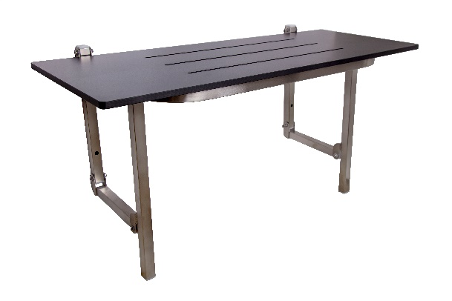
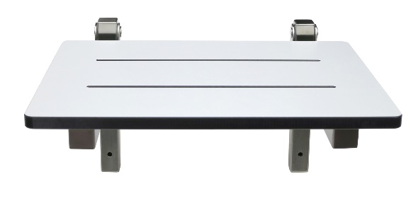

General Cleaning
To maintain the appearance of the shower seat surface, wipe the surface with a damp soft cloth or sponge. You may also use a mixture of warm water and mild detergent.
After cleaning, wipe the surface with a dry soft absorbent cloth.

What to avoid
- Rubbing with steel wool (wire wool) or scraping with steel tools
- Using concentrated bleach or hydrochloric acid-based cleaning products
- Abrasive cleaners
- Acidic cleaners
- Metal cleaners

General Cleaning for stainless steel
For everyday cleaning, wipe the surface with a damp soft cloth or sponge. You may also use a mixture of warm water and mild Neutral pH soap or detergent (such as PZ Cussons Morning Fresh).
After cleaning, wipe the surface dry with a soft absorbent cloth.

Avoid Scratches
Stainless Steel can be scratched by careless handling aggressive scrubbing. Avoid dragging rough items across the surface and be aware that grit trapped under other materials can cause surface scratches.

Chemical Reaction
If left in contact with salts or acids for extended periods, Metlam Australia Stainless Steel products may be compromised. Applying regular hygiene measures, like a maintenance/cleaning schedule, will minimise any potential problems.
Using incorrect cleaning products can damage your Metlam Australia stainless steel product and void the warranty.

AVOID
- Rubbing with steel wool (wire wool) or scraping with steel tools.
- Using scourers and cleaning cloths that have been used on ordinary steel.
- Rubbing plastic scourers across the grain of brushed surfaces.
- Using concentrated bleach or hydrochloric acid-based cleaning products.
- Contact with products containing chlorine bleach, hydrochloric or muriatic acid.

